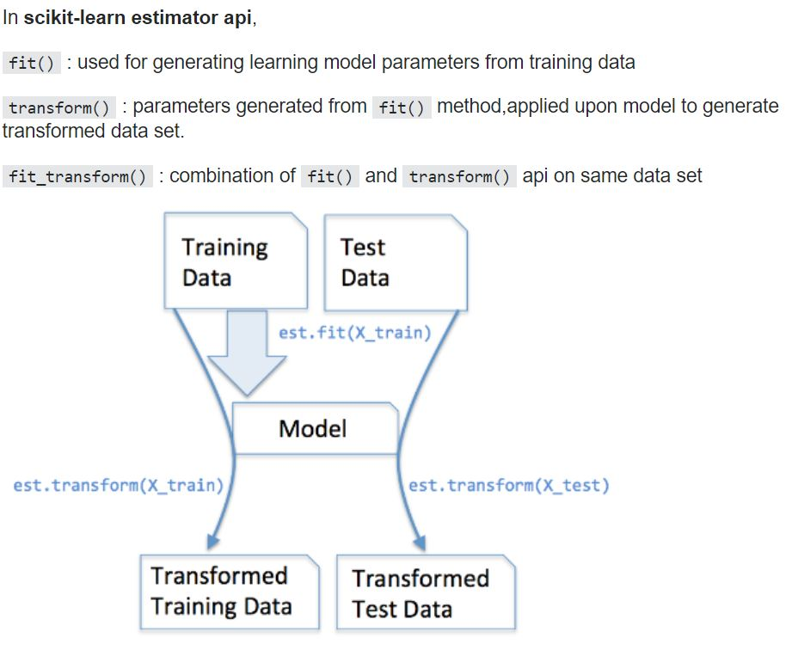

We will be doing the pre-processing on the input data to change into some-other format. And these format is used for model training.

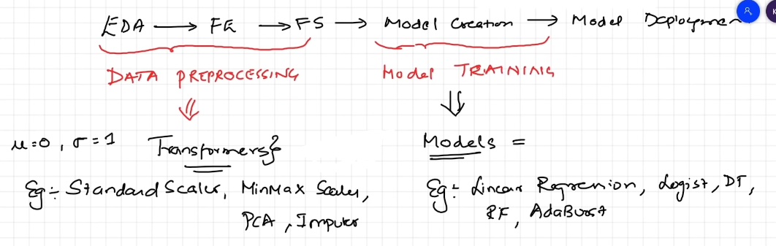



Will perform transform only when we want to do some transformation on the input data.

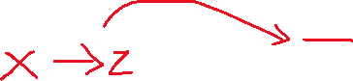

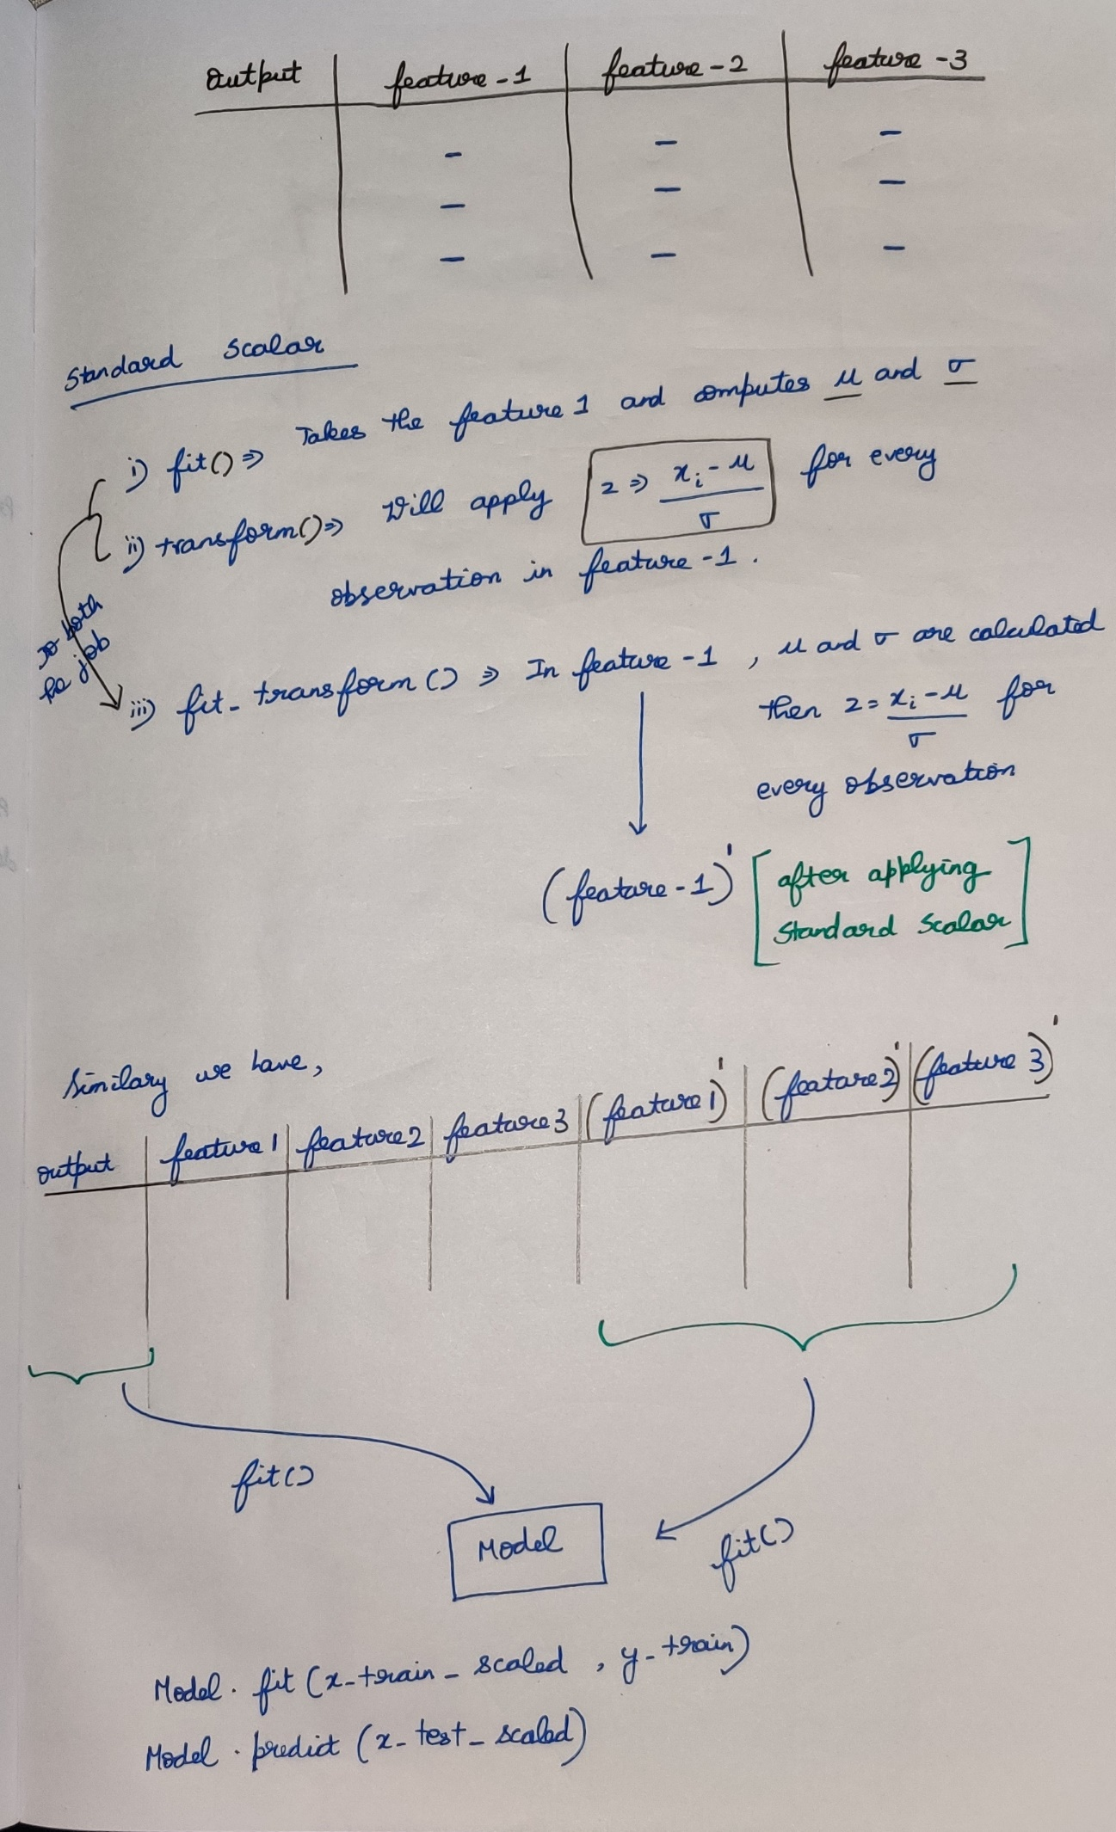



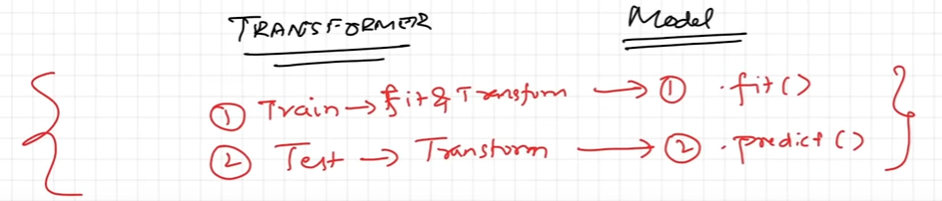



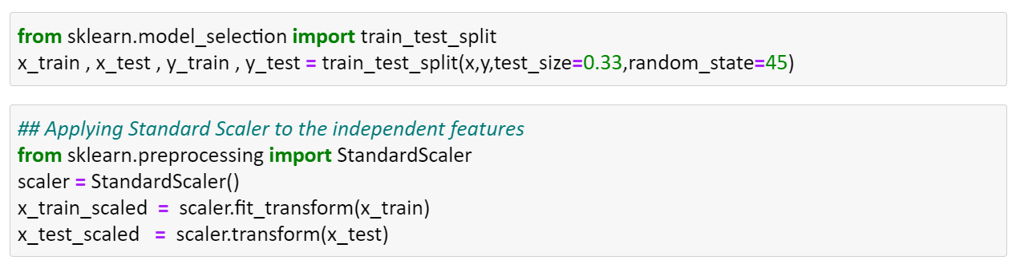

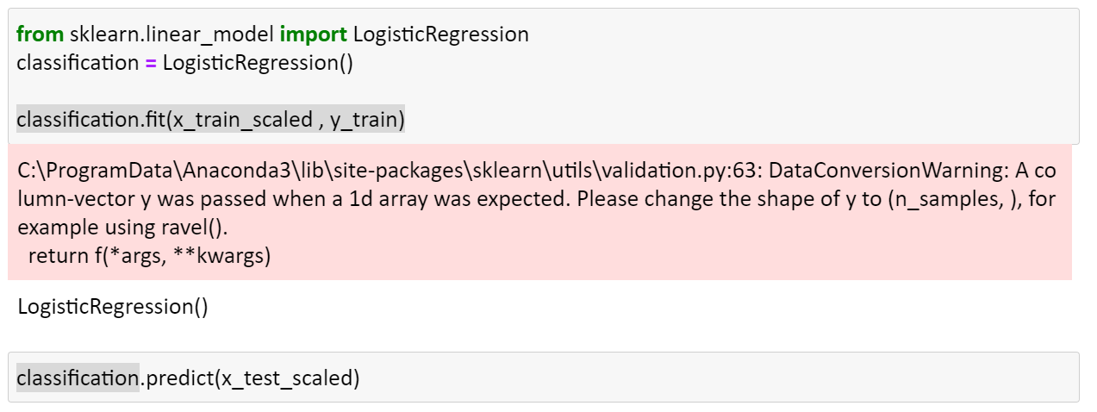

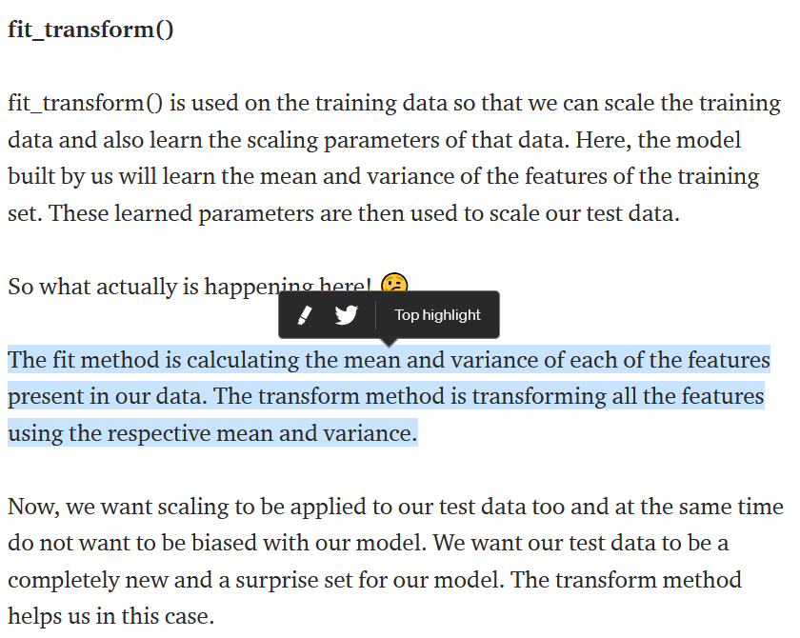

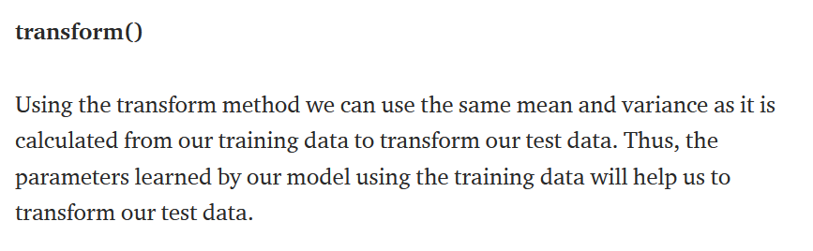

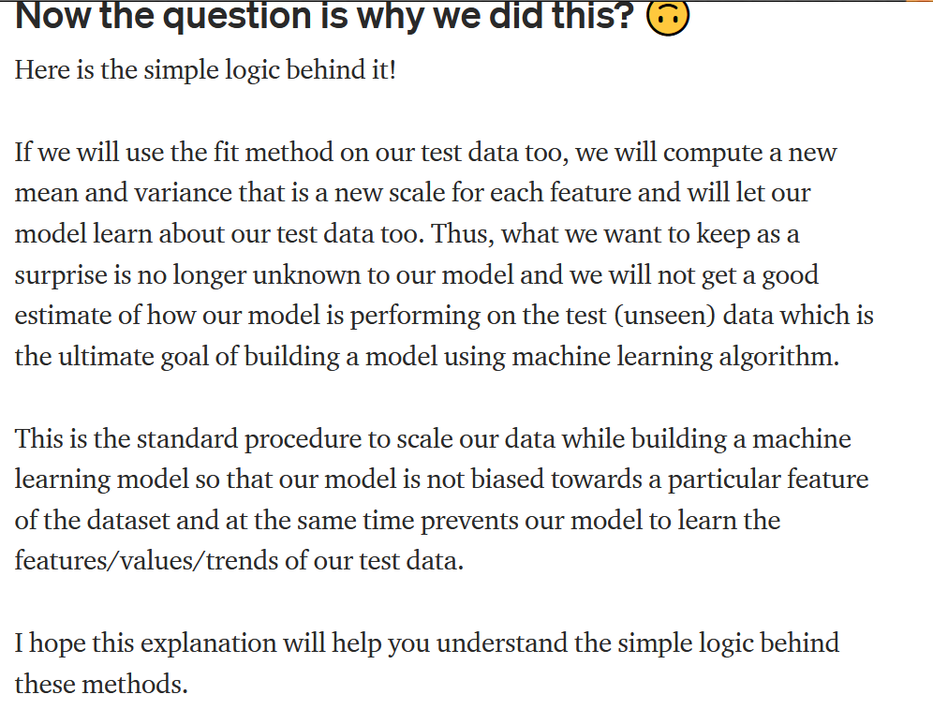



[..\audio_recordings\fit()_transform()_fit_transform().mp4](../audio_recordings/fit()_transform()_fit_transform().mp4)

References  
<https://www.youtube.com/watch?v=BotYLBQfd5M&t=527s>

<https://towardsdatascience.com/what-and-why-behind-fit-transform-vs-transform-in-scikit-learn-78f915cf96fe>